**Games to support the Big Ideas in Computing.** We have created E-Learning Games to support the big Ideas in computing. ELearning is becoming an increasingly important teaching and learning method in educational institutions, to provide better access to high quality course materials, especially in K-12 system. As enrollment in high school STEM courses have increased substantially, the percentage of high school students who pursue computer science major is lower many other STEM areas but there is a great need for students to be proficient in Computer Sciences. Our games are created to support university outreach efforts that have begun to get more students interested in computing sciences. We have studied some of the Big Ideas in computing and the Beauty and Joy of Computing projects and our aim is to provide an educational platform to support informal and engaging curricula for high school students in computing, and getting them into practice through digital simulations, education games, videos, tutorials and interactive educational activities.

We need an even larger proportion of students trained to support continued growth in various computing technology fields and to pursue versatile computing careers in this high technology-driven society. Recently technology has become a prime necessity in the classroom, as it plays an important role in helping young people to achieve promising careers. The use of technology allows educators to showcase more information in creative forms. E-Learning has proven as one of the most significant new instructional approaches available, which drives progress in both teaching and learning process in America's K-12 schools today. E-Learning is delivered and supported using a variety of electronic media and we propose educational games as our approach to adding more interest to E-Learning Materials.

|  |  |
| --- | --- |
| Big Ideas in Computing | |
| Creativity | Computing is a creative activity that promotes innovation and exploration. |
| Abstraction | A central problem solving technique that reduces information and details to focus on concepts relevant to understanding the problem. |
| Data | Information that facilitates knowledge about the world. |
| Algorithms | Tools for expressing solutions to computational problems. |
| Programming | Creative process that produces computational artifacts. |
| Internet | Digital devices, systems and networks that interconnect to enable computational problem solving. |
| Impact | Computation has had a profound impact on the way people live, work, play and think. Computing has enabled major innovations in other fields including medicine, engineering, science and even the arts. |

[AP, The College Board <https://apstudent.collegeboard.org/apcourse/ap-computer-science-principles/course-details> ]

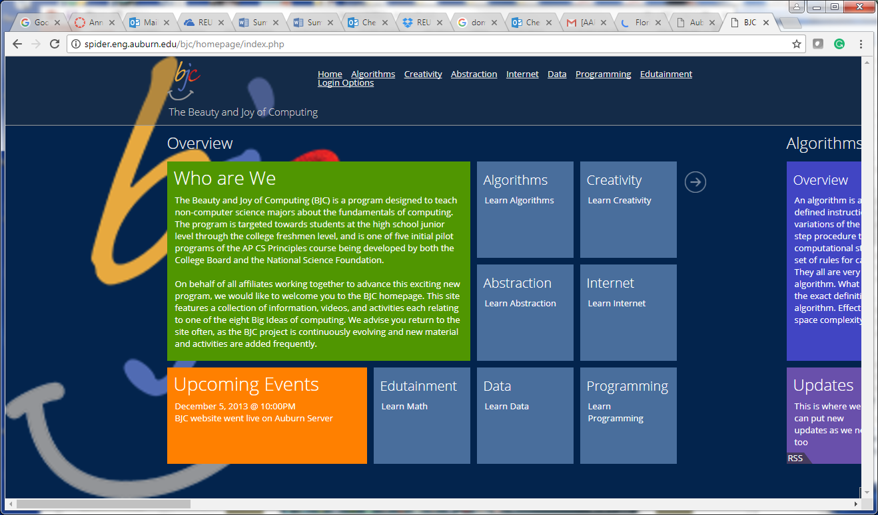E-Learning allow us to deliver individualized and comprehensive learning content that facilitates learning, anytime and anywhere. It does not replace the traditional classroom approach, but creates an augmented learning environment. This approach rather promotes combined usage of teaching techniques in order to maximize the student's participation in the learning process. The student will go beyond the limits imposed by traditional classroom of time and place, provided broader access to the learning materials.

**Beauty and Joy of Computing ~ Auburn Version to support 7 Big Ideas in Computing**

**[http://spider.eng.auburn.edu/bjc/homepage/index.php]**

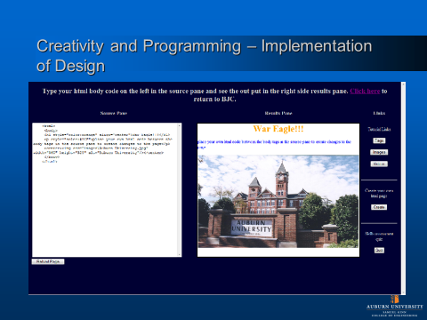

**Educational Game to website design and development with html**

**[Spider Auburn BJC]**

The Beauty and Joy of Computing (BJC) was coined by bjc.berkeley edu project to support the 7 Big Ideas in computing. The BJC – The Beauty and Joy of Computing project was been designed to help with some of these issues. It is a Web based computer science teaching aid developed based on the CS Principles project Big Ideas in computing which is a joint project between a team of computer science educators organized by the College Board and the National Science Foundation. The project focuses on presenting the seven big ideas in computing (creativity, abstraction, data, algorithms, programming, internet and impact) in new and innovative ways. The aim of the project is to broaden interest in computer science at the high school level through new and engaging teaching aids that will hopefully foster an interest to pursue a career in a computer science field after high school. The BJC project takes these ideas and incorporates them into a Web-based environment that is accessible to students and educators anytime and anywhere. It unites mobile e-Learning with games, tutorials and video content that is designed to be fun and engaging while at the same time teaching the user key concepts in computer science.

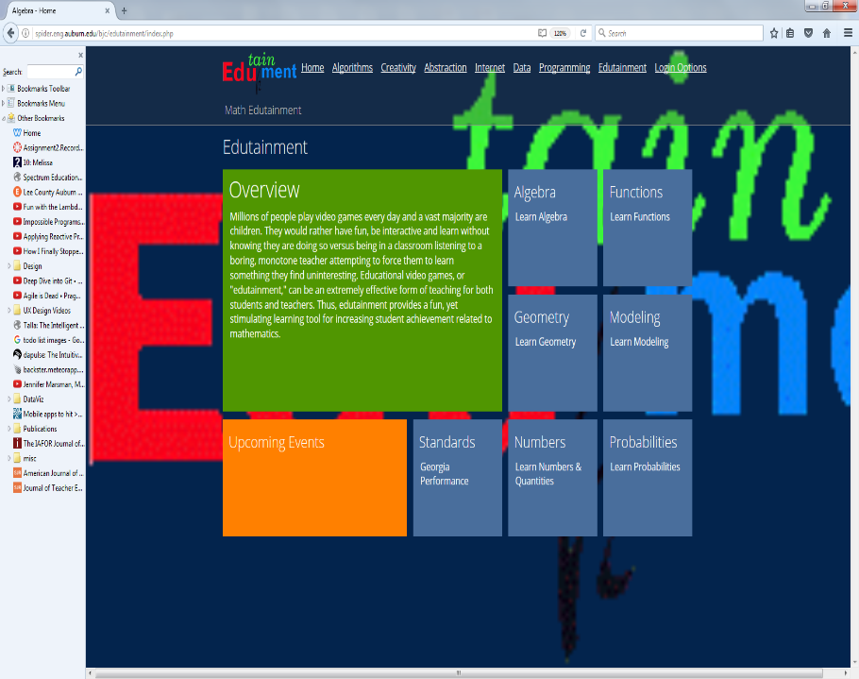Our website was initially designed as a website for the preliminary work of this project. Our version of the Beauty and Joy of Computing was to provide educational games and interactivities that were ready to use by teachers and their students to introduce them to the central idea of computing and computer science. It tries to instill the idea of computational thinking, and also to get students involved in divergent activities that showcase the impact of computing on the world. The main goal is to engage students in the creative aspects of the world through computing and E-Learning games. Students will gain some experience in computer concepts and develop ability to solve problems and find creative solutions supported by technology. This project will provide a platform to aid teaching in schools, by providing informal curriculum in computing. These E-Learning Games will promote student's pursuit of Computer Science. This will provide a foundation of 7 topics that students can as a foundation for learning about game development and the game products that they create will support the growth of learning materials to support computational thinking and training that would be appropriate for a CS0 instructional course unit. We then expanded this website to support other STEM disciplines and Edutainment version was created to support introductory math concepts based on the Georgia an Alabama 8th and 9th grade Algebra content standards. With this we have ample topics that can be supported as our aim is to turn introductory algebra into multiple educational games. **Edutainment AU to support Algebra & Geometry**

**[Spider Auburn BJC]**

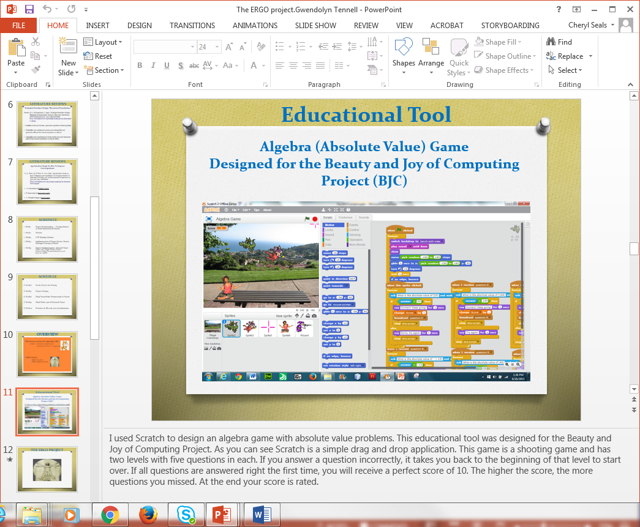

**Absolute Value Game created in Scratch [Spider Auburn Edutainment]**

We also have created games to teach mathematics to small children. SMART-Tetris was created to teach area and perimeter to young children through an educational game. SMART-Tetris motivates students to be motivated by a sense of competition as an intrinsic motivation for students to acquire new skill through a stealthy approach to learning. According to Scales and Varnado active learning occurs when “students are involved in more than listening, less emphasis is placed on transmitting information and more on developing students' skills, students are involved in higher-order thinking (analysis, synthesis, evaluation), students are engaged in activities (e.g., reading discussing, writing), and greater emphasis is placed on students' exploration of their own attitudes and values [McKinney].” Education can be enhanced as a result of students becoming more active in the classroom through hands on and interactive tasks. In a number of schools teachers do not emphasize active learning because the teacher may be inexperienced in teaching this type of learning as active learning can require more teacher time in preparation of these types of activities. Classrooms that encourage cooperative action and collaborative problem-solving through discussions and reflections, can lead to achieving better results in students comprehending information that the teacher has lectured on [Niemi].

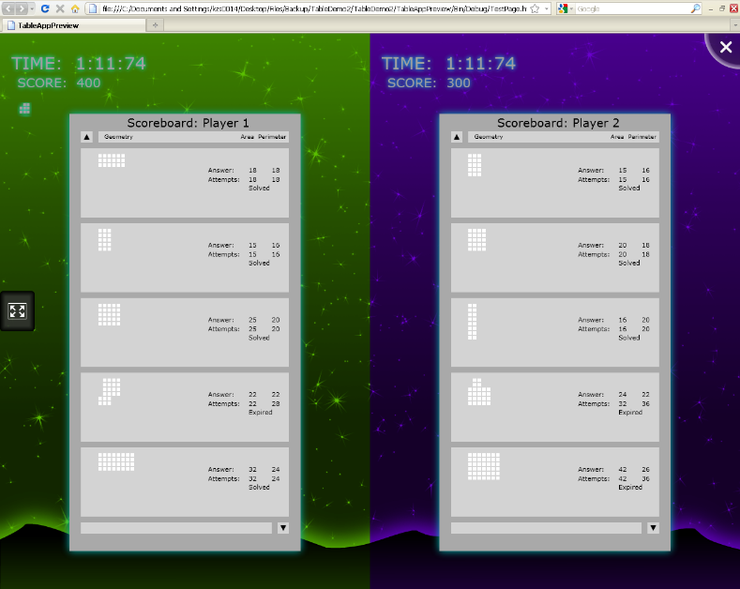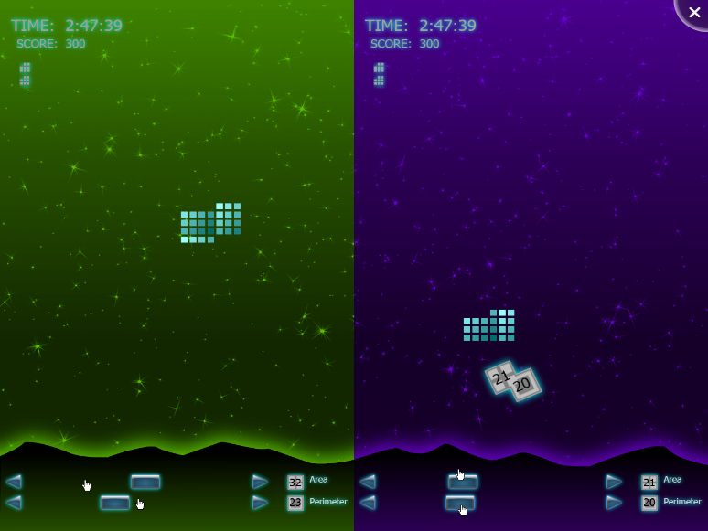Currently SMART Technologies products have become well-liked in a large number of classrooms. I have participated in outreach in the local community and I have observed that in several classrooms the teacher would utilize a SMART Whiteboard. There have been more than 1 million SMART Board interactive whiteboards used around the world and these days over 25 million students learn with products made by SMART. SMART products are not only being used in every US state, they are additionally being utilized in more than 170 countries according to SMART Action Research. Someone might contemplate which is better active learning or passive learning in regards to a learners overall learning experience? The solution to this matter is that it depends more upon that particular student. In a significant number of our classrooms, we are taught by a passive traditional method of learning. Passive learning places more emphasis on remembering material, but less independence is given to the student. The student can lose interest with traditional education with little interaction and discussion in the classroom. This leads to some of the learners occasionally looking at the teacher and more likely not paying as much attention to lecture material. Likewise due to the student lack of engagement the student may encounter boredom and become disinterested in being in the classroom [McKeachie]. Earlier in this report, it was pointed out that there continues to be a challenge of maintaining the focus of attention among young students in school [SMARTtech]. The SMART Table is a great tool for active learning. According to Figure 1, we remember 70% of what we say when we communicate our thoughts to others around us. In addition we also remember 90% of what we say and do when we get engaged in that particular activity. Hence, the SMART Table achieves the incredible task of maintaining the attention of younger children [McKeachie]. SMART Table is capable of 2-6 students cooperating with each other in learning a new skill [SMARTtech]. The SMART Table can be used by teachers and students to portray a presentation of a subject covering concepts that the student has recently been taught. The SMART Table is impressive for the reason that this technology makes it possible for instantaneous interaction among students according to Smart Action Research. We created an educational game to teach area and perimeter to small children utilizing the theme of the popular game Tetris to keep the students engaged in the learning process and 2-6 students can compete at time in the learning exercises. The figures illustrate the Tetris screenshot and the end of game results screenshot. Our active learning game will get the students more involved in more than just listening, to lectures and less emphasis is placed on transmitting information and more on developing students' skills, students are involved in higher-order thinking (analysis, synthesis, evaluation), students are engaged in activities (e.g., reading discussing, writing), and greater emphasis is placed on students' exploration of their own attitudes and values.

**References**

E. **Adams**, Fundamentals of Game Design, New Riders Berkeley:,2010.

N. **Carolina**, E. Murphy-hill, T. Zimmermann, N. Nagappan, "Cowboys Ankle Sprains and Keepers of Quality: How Is Video Game Development Different from Software Development?", *Proceedings of the 36th International Conference on Software Engineering*, pp. 1-11, 2014.

M. **Dymek**, "Content Strategies of the Future: Between Games and Stories – Crossroads for the Video Game Industry", *3rd International Conference on Digital Interactive Media in Entertainment and Arts*, pp. 420-426, 2008.

J. **Kasurinen**, A. Maglyas, K. Smolander, "in Game Development?”, *International Working Conference on Requirements Engineering: Foundation for Software Quality*, pp. 1-16, 2014.

**Niemi**, H. Active learning—a cultural change needed in teacher education and schools. <http://www.sciencedirect.com/science?_ob=ArticleURL&_udi=B6VD8-46Y4BMX-3&_user=409620&_coverDate=10%2F31%2F2002&_rdoc=1&_fmt=high&_orig=search&_sort=d&_docanchor=&view=c&_searchStrId=1369611993&_rerunOrigin=scholar.google&_acct=C000019518&_version=1&_urlVersion=0&_userid=409620&md5=9ec3347b60f0a5fc9dd1777b85302cba>

**McKinney**, K. Examining Active Learning Active Learning. https://www.google.com/url?sa=t&rct=j&q=&esrc=s&source=web&cd=1&cad=rja&uact=8&ved=0ahUKEwiz-MXomOvVAhWE5CYKHSYbDwAQFggoMAA&url=http%3A%2F%2Fedgd.asee.org%2Fconferences%2Fproceedings%2F66th%2520Midyear%2FExamining%2520Active%2520Learning_Review%2520and%2520Current%2520Thinking_Scales%2520Varnado_66th%2520EDGD%2520Proceedings.pdf&usg=AFQjCNHG7sS4xPeB8KqjyNKcN0NxF2BwUQ

**McKeachie,** W.J. Active Learning.

<http://courses.science.fau.edu/~rjordan/active_learning.htm>

**SmartTech**. <http://vault.smarttech.com/ecoweb0908/1-preso/index.html>

**SMART** Action Research. <http://downloads01.smarttech.com/media/edcompass/may2010/smartactionresearch.pdf>

**Spider,** Auburn BJC. http://spider.eng.auburn.edu/bjc/homepage/index.php

Advanced Placement **(AP),** The College Board, AP Computer Science Principles, retrieved on July 22, 2017. https://apstudent.collegeboard.org/apcourse/ap-computer-science-principles/course-details